Yohanes Dimas Pratama

A11.2021.13254 - A15.9102

***UTS Business English***

On a sunny morning in June, my family and I were getting ready for a much-awaited holiday trip to the city of Yogyakarta, Indonesia. We have planned this vacation before, and now it's time to explore the cultural and natural beauty of this city.



Our first day in Yogyakarta started with a visit to Prambanan Temple. We were mesmerized by the splendor of this temple built in the 9th century. Prambanan Temple is one of Indonesia's cultural heritage and was the perfect place to start our adventure. We wandered around the temple complex, taking photos of the majestic statues and beautiful architecture. The event ended with a stunning Ramayana dance performance in the evening.

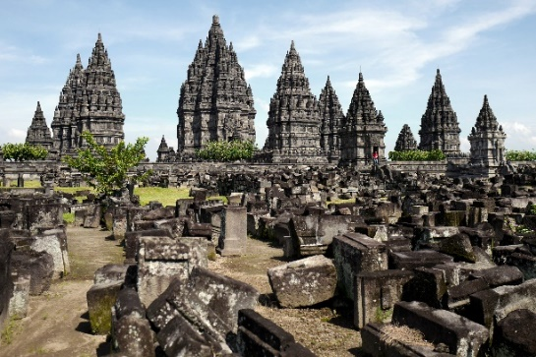

Our second day was spent at Kraton, the traditional palace of the Sultan of Yogyakarta. We strolled through the beautiful grounds, visited the palace museum which displays a collection of historical artifacts, and enjoyed a very interesting shadow puppet show. We also tasted delicious Yogyakarta dishes, such as gudeg and fried chicken. We felt as if we had traveled back in time to the past.

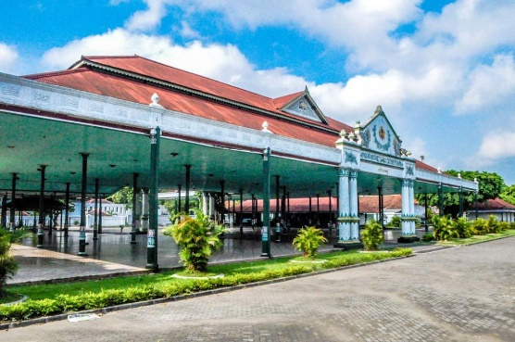

On the third day, we visited one of the most iconic places in Yogyakarta, namely Borobudur Temple. We arrived there at sunrise, and the view of the sun rising behind Borobudur Temple was a very impressive moment. We wandered through the temple terraces, admiring the beautiful reliefs and trying to understand the cultural meanings contained within them.

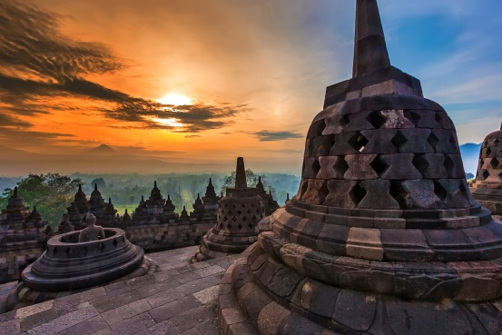

For the rest of our holiday, we explored the Malioboro area which is famous for its souvenir shopping, culinary delights and street entertainment. We also visited Parangtritis Beach and enjoyed the amazing sunset while playing in the sand on the beach.

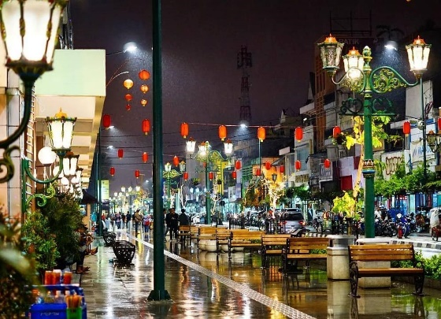

Another unforgettable experience was our visit to Jomblang Cave. We explored this cave with a special tour that leads into the darkness. When natural light shines into the cave, we can see the beauty of the stalactites and stalagmites that have formed over thousands of years. Jomblang Cave is a unique and enchanting place.

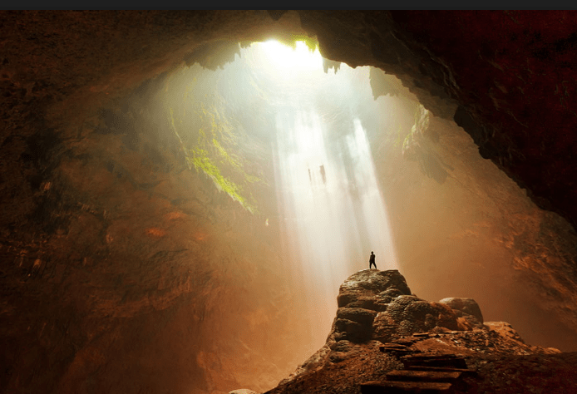

Our holiday in Yogyakarta was truly unforgettable. We were not only blown away by the city's rich culture and history, but also by the friendliness of its people. We took home beautiful memories and stories that we will share with our friends and family. Yogyakarta is a very special city, and we hope to return one day to continue our adventure.